

SCHOOL OF COMPUTING AND INFORMATION TECHNOLOGY

Bachelor of Technology
in
AIML/CSIT/CSSE/ISE

Major Project Phase-I Synopsis

(AI-Augmented Observability System for ISP)

By
Bhargava A – R22EK003
Basavaraj R Bagewadi - R22EK030
Krithika S - R22ER072
M K Varun Gowda - R22EK040

Under the supervision of

Prof. Kavita Babalad

School of Computing and Information Technology

Rukmini Knowledge Park, Kattigenahalli,
Yelahanka, Bengaluru-560064
Rukmini Knowledge Park, Kattigenahalli, Yelahanka, Bengaluru-560064
www.reva.edu.in
November 2025
- Introduction:
In modern digital infrastructures, network traffic is growing at an unprecedented pace. With the rapid expansion of cloud services, online education platforms, remote research collaborations, and billions of internet-connected devices, today’s networks handle far more data than traditional monitoring systems were designed for. This continuous and exponential rise in traffic has increased the complexity of maintaining network performance, security, and reliability.

The importance of this project becomes clearer when looking at recent trends. Global connectivity has surged, and the number of internet-connected devices has grown significantly every year. The chart included in this section shows a sharp increase in IoT and internet-enabled devices between 2021 and 2025. This rise directly contributes to heavier network loads, unpredictable traffic patterns, and a larger surface area for network vulnerabilities.

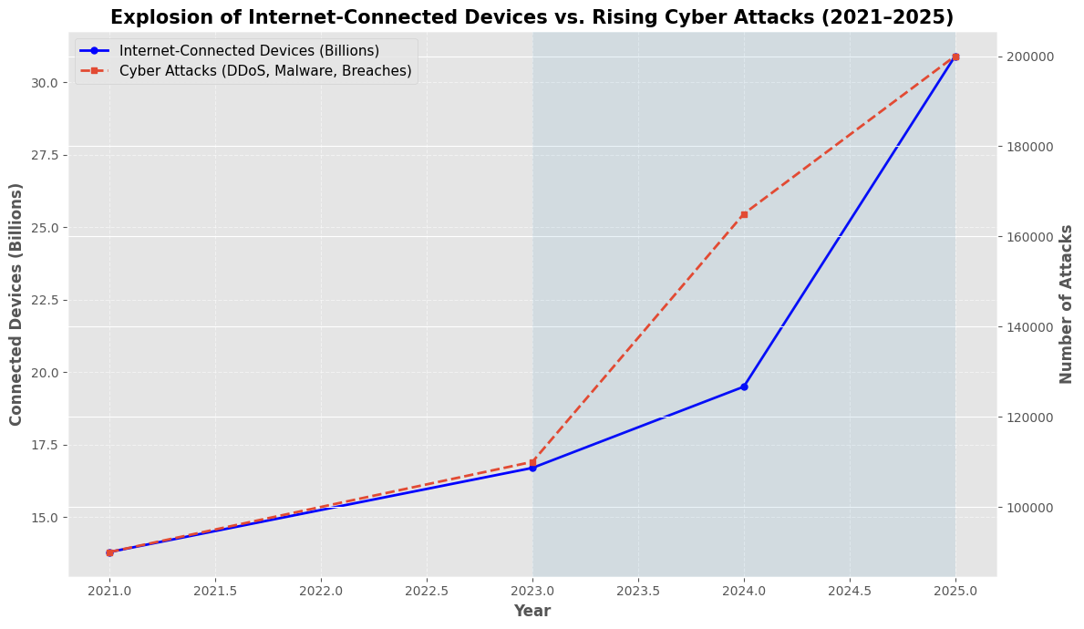
Fig 1. Network Traffic Pattern Over Time

Parallel to this growth, cyber-attacks — especially anomalies like DDoS floods, scanning spikes, and unusual traffic bursts — have also increased rapidly. As the chart indicates, the number of attack attempts is scaling alongside the growth of connected devices. This creates a critical challenge: more devices → more traffic → more potential anomalies, making manual monitoring insufficient.

These real-world trends highlight the need for advanced, intelligent observability systems. Traditional rule-based monitoring tools cannot adapt to constantly changing traffic patterns or detect anomalies hidden within massive volumes of data.
This project is built around addressing these challenges using real network data, open-source observability tools, and machine learning techniques to improve the accuracy, speed, and reliability of anomaly detection in large-scale academic and research networks.
- Problem Statement:
Modern networks are no longer small or predictable — they behave like live, fast-moving ecosystems. With millions of devices connecting every second and traffic patterns changing constantly, it has become extremely difficult for network teams to identify when something abnormal is happening.

The real problem is that traditional monitoring systems haven’t evolved at the same speed as the networks themselves. Most existing tools still depend on fixed rules, thresholds, or manual inspection. These methods simply cannot keep up with:
- sudden traffic spikes,
- evolving cyber-attacks like DDoS,
- unexpected routing issues,
- misconfigurations,
- and new usage patterns created by IoT and cloud-based systems.
Because of this gap, anomalies often go unnoticed until they break something — slow internet, unstable connections, service downtime, or security vulnerabilities.

This is a big issue because networks in universities, research institutions, and ISPs support thousands of users at the same time. Even a small anomaly can impact online classes, research data transfers, lab work, cloud services, and communication systems.

Our project solves this by moving away from static, rule-based monitoring and shifting toward AI-augmented anomaly detection. We first train and validate our models using the CESNET dataset (research-grade, high-quality time-series data), and once the system becomes stable, it can be applied to real-time, live ISP traffic with minimal modifications.

Who gets affected by this problem?
- Students & faculty (slow internet during labs or online classes)
- Research teams (failed large data transfers)
- Network admins (manual troubleshooting takes hours)
- ISPs (service degradation, customer impact)
This is why building an intelligent, automated, and scalable anomaly-detection system is not just useful — it's essential for modern networks.

- Scope and Objectives:

This project focuses on building an AI-Augmented Observability System that can detect abnormal network behavior in large ISP, university, and research environments.
The system is first developed using the CESNET dataset, but the architecture is designed in such a way that it can directly scale to real-time production traffic without major rework.

The scope includes:
- Collecting and analyzing high-volume network traffic data.
- Using ML models to detect anomalies.
- Integrating with real observability tools (ELK, Prometheus, Grafana).
- Expose ML-generated anomaly predictions through a REST API for easy external access and automation
- Designing a fully automated pipeline that replaces manual monitoring.
- Primary Objective:

To build an AI-augmented observability system that automatically detects anomalies in ISP-level network traffic and provides real-time insights through dashboards and ML-driven alerts.

Secondary Objectives:
1. Data Handling & Preprocessing
- Collect and clean raw CESNET traffic logs.
- Extract useful features (flows, packets, bytes, ratios, etc.).
2. Machine Learning for Anomaly Detection
- Train multiple ML models (ANN, Isolation Forest, One-Class SVM, Autoencoders).
- Compare which algorithm performs best for different anomaly types.
- Validate results against known traffic patterns.
3. Observability Integration
- Use Grafana, Kibana, Prometheus, ELK Stack for visualization.
- Build dashboards showing spikes, protocol imbalance, unusual patterns.
- Highlight anomalies in a way operators can understand quickly.
4. Real-Time Monitoring Pipeline
- After model training, integrate ML outputs into dashboards.
- Make predictions accessible through:
- internal scripts
- dashboards
- backend services
5. Transition to Real-Time ISP-like Data
- After academic dataset experimentation → adapt pipeline for live data ingestion.
- Add alerting mechanisms (spikes, thresholds, unusual ratios).
- Build a system that ISPs can plug directly into their existing monitoring workflow.

- Target Users:
Internet Service Providers (ISPs)
- Use the system to monitor large-scale traffic.
- Quickly detect DDoS spikes, abnormal bandwidth usage, and routing issues.
- Reduce downtime → save money → maintain SLA with customers.
University & Research Networks
- Ensure stable connectivity for students, researchers, labs, and cloud-based tools.
- Faster detection of traffic surges during peak academic hours.
- Protect critical research data from cyber threats.
Network Security Teams (SOC Teams)
- Replace repetitive manual log checking with automated insights.
- Respond faster to potential attacks or misconfigurations.
IT Infrastructure & Network Admins
- Get real-time dashboards (Grafana, Kibana) showing traffic trends and alerts.

- References :
Research Papers & Datasets
- CESNET Time Series 24 Dataset – High-speed academic network traffic logs used for anomaly detection.
- Lakhina, A., Crovella, M., & Diot, C. Mining anomalies using traffic feature distributions. ACM SIGCOMM.
- Chandola, V., Banerjee, A., & Kumar, V. Anomaly detection: A survey. ACM Computing Surveys.
- Xu, K., Zhang, Z., & Bhattacharyya, S. Internet traffic behavior profiling for network security monitoring. IEEE/ACM Transactions on Networking.
Machine Learning & Network Anomaly Detection
- Ahmed, E., et al. A survey on network anomaly detection using machine learning. Journal of Network & Computer Applications.
- Erfani, S. M., et al. High-dimensional anomaly detection using deep learning. IEEE TIFS.
- Breunig, M. M., et al. LOF: Local Outlier Factor. ACM SIGMOD.

